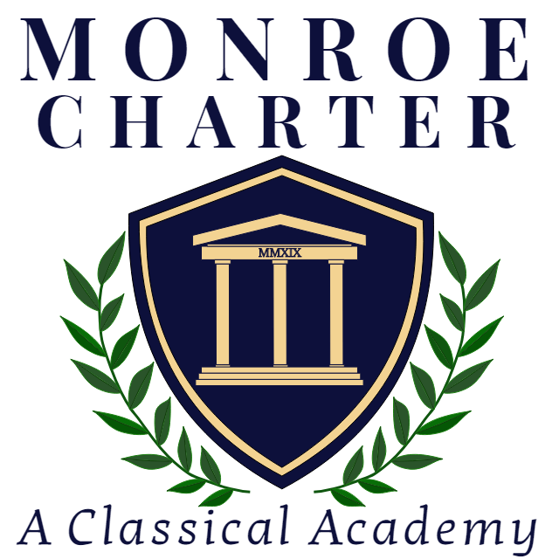
Monroe Charter Academy

Parent Guide to Student Achievement (PGSA)
Based on Parents’ Bill of Rights - SB 49; Session Law 2023-106

This guide is designed to answer many of the more frequently asked questions and to provide your family with some important resources. Please take time to review this information and if you have questions, please ask us for clarification. Classroom and grade-level procedures will be addressed by your child's teachers.

 | Information and Resources
How can my child be promoted to the next grade level? | In order to be promoted to the next grade level, Monroe Charter Academy students are expected to meet or exceed proficiency on local assessments of state standards and state standardized tests. Appropriate grade placement decisions are also based upon the mastery of critical knowledge and skills including reading, writing, and mathematics. The whole child is considered when making promotion decisions. Therefore, social/emotional needs and physical development are also considered. Final placement decisions are made by the Principal/Head of School, with input from teachers, parents and students (as practicable).
What is my child learning at school? How can a parent review these materials? | In North Carolina, all public schools use the same Standard Course of Study, determined by the State Board of Education. These standards are the knowledge and skills students should understand by the end of each grade/course.  The standards can be found on the NCDPI Office of Academic Standards website. Relevant standards for Monroe Charter Academy’s curriculum include:  - Arts Education,  - English Language Arts,  - Mathematics,  - Science, and  - Social Studies  Monroe Charter Academy and teachers determine how to teach these standards, including curriculum, textbooks, and supplementary materials.  Parents of Monroe Charter Academy students can learn more about our curriculum by attending the New Family Orientation session in the spring and the Open House/Curriculum Night session in the Fall ,and by reading the grade level newsletters.
How will a parent learn about my child’s progress in school or with a class? | Monroe Charter Academy shares student progress through a variety of ways, including report cards after each quarter, progress reports, parent conferences and assignment/test feedback. Parents of elementary/middle school students can also check Infinite Campus for information on student progress and performance. Feedback on conduct is also provided through personal emails and phone calls.  Local Assessments:  Monroe Charter Academy uses the mCLASS literacy assessment three times per year to measure reading achievement and progress in grades K-5. The school also uses Edmentum to measure progress in literacy in grades K-8. The school uses NWEA MAP to measure progress in literacy and math in grades K-8. Reports from these assessments may be sent home with report cards, and/or reviewed during parent conferences.  State Assessments:  Individual Student Reports for end-of-grade/course tests and other state assessments (English language proficiency assessment) are provided to parents at the end of each school year.  In NC, all students take end-of-grade (EOG) assessments for reading and math in grades 3-8. Students take EOG science assessments in grades 5 and 8. All students taking Math 1 are also required to take an end-of-course (EOC) assessment.  An Individual Reading Plan (IRP) will be developed for any in third grade demonstrating difficulty with reading. An IRP will have specific strategies/ideas that can also be supported at home.
What are the qualifications of my child’s teachers? | All MCS teachers are licensed and qualified to teach pursuant to State law.  You may look up your child’s teacher licensure status at this website:  Link to the licensure website  Please contact the Head of School if you have questions about an educator’s licensure status.
What are the requirements for school enrollment? What are the immunizations needed or recommended for children? | Please see our Admissions website for information on the requirements for school enrollment and the lottery process.  The following are statutory requirements for immunizations:  - Immunization records: GS_130A-155.pdf (ncleg.gov)  - Immunization requirements: GS_130A-152.pdf (ncleg.gov)  Questions or concerns about medical issues should be addressed to our school nurse, Ms. Leigh Ammons, at lammons@magellancharter.org.
How can a parent help their child learn and make progress? | Engaging with your child about school and what they are learning is pivotal to their learning process.  - Ask questions daily about your child’s school day.  - Inquire about topics and assignments they are learning.  - Connect with teachers to understand your child’s progress.  - Ask the teachers how you can help your child learn.  - Attend different events at our school to stay connected and learn how to support your child.  Local Resources:  - Literacy at Home  - Tips for Literacy  - MTSS  Parent Guides for Academic Standards:  The following grade level guides contain information to support  parents and caregivers with understanding the North Carolina Standard Course of Study. The purpose of these guides is to inform parents about the standards, as well as provide useful strategies to incorporate at home.  ELA Parent Guides  ELD Parent Guide  Math Parent Guides: K-5, 6-8  Social Studies Parent Guides (coming soon)  Science Parent Guide (coming soon)  Reading and Literacy Support:  The following site provides resources for families to practice and reinforce important literacy skills with their children who are being assessed with mCLASS reading assessments: Amplify Parent Resources  Home activities, printables, and games to support reading and literacy are also available at North Carolina’s Digital Children’s Reading Initiative (DCRI). These activities include the following topics, Pre-K-Grade 5:  (1) Phonemic awareness  (2) Phonics  (3) Vocabulary  (4) Fluency  (5) Comprehension  (6) Oral language
How can a parent help their child develop citizenship, social skills and respect for others? | Monroe Charter Academy conducts daily Morning Meetings in all grades in order to develop citizenship and explicitly teach social skills and our core values of respect, responsibility, and integrity.  Our school is also partnered with The Positivity Project. This partnership provides resources, strategy, and training to teach students positive psychology’s 24 character strengths and empower our students to build positive relationships.  Please contact our school counselors if you have any questions about the TSI curriculum and resources.
How can a parent help their child meet high expectations and set and reach lifelong goals? | Monroe Charter Academy embeds Portrait of a Graduate skills in the classroom and school setting. These durable skills were developed by NCDPI and support a child’s realization of high expectations and setting lifelong learning goals. NC Portrait of a Graduate - Durable Skills.  Grade level specific resources from the Positivity Project can be found in the following resource repository for families: https://posproject.org/p2-for-families/
How can a parent strengthen communication with the school and their child’s teachers? | Monroe Charter Academy uses the following platforms for communication between home/school  - Infinite Campus and Remind to send Voice and Text messages  - Please see our Communication section in our Student-Parent Handbook  Parents can view students’ assignments and grades in the Infinite Campus parent portal.  The following are NCDPI developed parent guides that provide suggestions for building strong relationships with your child’s teacher and supporting communication between home and school.  Building Strong Relationships with Your Child’s Teacher (NC Rethink Education Program)  How You Can Use Questions to Support Your Child’s Learning (NC Rethink Education Program)  Additional general parent guides and parent resource webinar recordings can be found at the following website.
What services are available for parents and their children? | Monroe Charter Academy  - After School  Middle School Tutoring: NCVPS EdVantage Tutoring offers virtual statewide wraparound support to middle and high school students in NC public schools. Tutoring is available in Math, Science and ELA, and is offered via a personalized partnership with district/school leadership to best meet the needs of selected students each semester.
What are opportunities for parents to participate with school? | We believe a strong parent/school partnership is critical to a dynamic learning environment and success for each child. Parent support is fundamental to all we do, and we rely on volunteers for many aspects of day-to- day life at Monroe Charter Academy. We need every family’s commitment to generously give of their time, talents and resources to maintain a strong community and continue Monroe Charter Academy’s legacy of excellence. Please see our website for ongoing volunteer opportunities: https://monroecharteracademy.org/volunteer/
How can I learn more about the challenging academic programs available to my child? | Monroe Charter Academy offers a variety of options for students to pursue their interests and strengthen their academic skills. Please see our Middle School Math website to learn about the program offerings and accelerated math pathways we offer in grades 6-8.  NCVPS:  North Carolina Virtual Public School (NCVPS) is NC’s state supplemental program and leader in online education, providing inclusive learning opportunities for students across the state. Founded in 2007, with a strong commitment to ensuring quality education for all students, regardless of location, NCVPS has over 16 years of experience serving diverse learners.  Magellan Charter School offers the following courses through NCVPS:  - Math 1 (as needed)
What school choices are available for my child? | Charter Schools  Charter schools are public schools of choice that are authorized by the State Board of Education and operated by independent non-profit boards of directors. State and local tax dollars are the primary funding sources for charter schools, which have open enrollment and cannot discriminate in admissions, associate with any religion or religious group, or charge-tuition. Charter schools operate with freedom from many of the regulations that govern district schools, but charter schools are held accountable through the State assessment and accountability system.  Nonpublic Education and Scholarship Grants  Nonpublic education is overseen by the NC Department of Administration.  For a list of private schools, visit this NC Private Schools.  For information on how to start a homeschool visit:  Homeschool Information  Scholarship grant programs/voucher information is available via the NC State Education Assistance Authority.
What rights do students with disabilities have based on the law? | For students suspected of or identified with a disability by the Individuals with Disabilities Education Act (IDEA), the following links provide important information regarding the procedural safeguards available to ensure a free, appropriate, public education.  Parent Rights Handbook  Parent Rights Handbook (Spanish)  IDEA Dispute Resolution  Special Education Surrogate Parents  Project Child Find  Monroe Charter Academy Special Program
What is the contact information for the school? | Monroe Charter Academy  7513 Broomes Old Mill Road, Waxhaw, NC 28173  Phone: 919.844.0277 | Fax: 919.844.3882  Please also see the Student-Parent Handbook for a list of our Faculty and Staff Members, and our Board of Directors.

